# DVRAS Calibration

The Broadband VLF receiver installation on SANAE IV uses magnetic induction to monitor incoming VLF signals. Data are used for studying, amongst others, the association of VLF chorus with sub storm particle injections, the occurrence of VLF whistlers and their relation to their source in lightning, the measurement of magnetospheric electric fields from the drifting of plasma duct enhancements, as well the study of wave induced electron precipitation. The installation must receive a yearly calibration each austral summer.

## Dummy Antenna Calibration

For this procedure the system noise, sensitivity and frequency response of the system is determined by disconnecting the loops and connecting a dummy antenna to the preamplifier.

### Equipment

The following equipment will be required to perform the calibration procedure:

* Two VHF radios
* Function generator (load impedance should be set to HIGH-Z)
* Magnetic Compass / GPS
* Dummy Antenna

### Base Preparations

The following steps need to be completed in the base before starting the calibration procedure.

1. On computer, turn off recording, with kill ’cat /tmp/dvrec.pid’
2. Connect signal generator to cable coming from the antenna as shown in *Figure 1*.

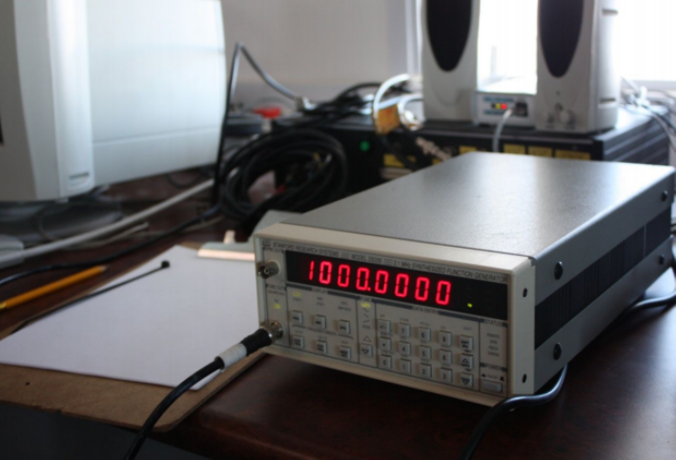

Figure 1. Function generator connected to incoming unterminated coaxial cable.

1. Get two radios, one to the lab group, one to the antenna group.
2. Set the load impedance on the ‘Stanford Research Systems’ signal generator to HIGH Z.
3. Set amplitude on signal generator to 0.6 Vrms.
4. Check that parallel cable to the CALTONE generator is disconnected.

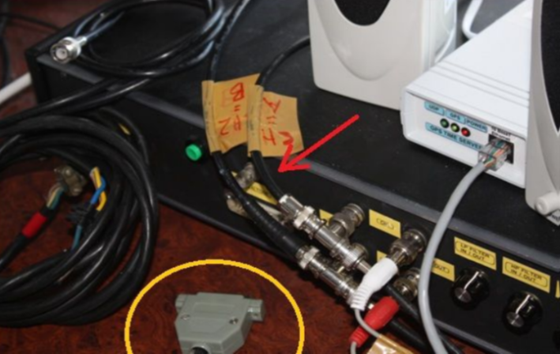

Figure 2. Disconnected parallel cable for caltone generator.

1. Set INPUT ATTENUATOR on the goniometer signal conditioner to 0 dB *Figure 3*.



Figure 3. Input attenuator set to zero, both filters in OUT position.

1. Make sure both the low pass and high pass filters are in “OUT” position.

### Field Preparations

Complete the following preparations out in the field before starting the calibration procedure:

1. Disconnect NS and EW antennas from the preamplifier in the hatch.
2. Replace NS loop connection with dummy antenna, see Figure 4 and Figure 5.



Figure 4. Dummy antenna units.



Figure 5. Dummy antenna connected to preamplifier in the field.

1. Connect the white marked cable with BNC connector to the dummy antenna.

### Procedure

1. Start ‘dvcalibrate’ on the PC.
2. Double check that the parallel cable to the caltone generator is disconnected, press ‘y’.
3. Ensure that the north south loop is on channel one.
4. Put in 0.6 for reference RMS voltage and define other voltages as shown in *Table 1*.

Table 1. Voltage readings.

|  |  |  |
| --- | --- | --- |
| Amplitude | Voltage | Use |
| -5 dB | 0.337405 Vrms | 0.34 |
| -10 dB | 0.189737 Vrms | 0.19 |
| -15 dB | 0.106697 Vrms | 0.11 |
| -20 dB | 0.060000 Vrms | 0.06 |
| -25 dB | 0.033740 Vrms | 0 |
| -30 dB | 0.018974 Vrms | 0 |
| -35 dB | 0.010670 Vrms | 0 |
| -40 dB | 0.006000 Vrms | 0 |
| -45 dB | 0.003374 Vrms | 0 |

1. For system noise: Turn off function generator, press enter, and record system noise for required time interval.
2. Sensitivity: Turn on function generator, and for each frequency / amplitude pair adjust the generator. After each adjustment, press enter and record. MAKE SURE FREQUENCY ON SIGNAL GENERATOR IS IN THE RIGHT UNIT (kHz).
3. Proceed to frequency response, where the amplitude remains fixed at the reference value of 0.6V and only the frequency is adjusted.
4. In the field: After N/S responses are complete, change the dummy loop antenna from the North South connectors to the East West connectors.
5. Repeat procedure for E/W connectors.

## Coil Calibration

A calibration coil is utilised, where a known offset is sent into the system and the responses, sensitivities and noise are recorded.

### Equipment

* Two VHF radios
* Function generator (load impedance should be set to HIGH Z)
* Magnetic compass / GPS
* Impedance matching unit
* Calibration mirrors
* Light source (headlamp, torch)
* Calibration pole (sectioned in two, terminated with a slotted copper fitting)
* Step ladder
* Tall individual

### Base Preparations

Complete the following preparations inside the base before starting with the coil calibration procedure:

1. Connect impedance matching unit to the calibration coil with the incoming coaxial cable marked “calibration coil”, as depicted in the diagram below *Figure 6*: Impedance matching unit Diagram

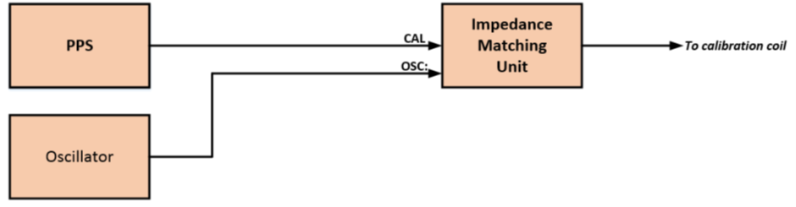

Figure 6. Impedance matching unit diagram.

1. Connect the function generator and the CALTONE generator to the impedance matching unit, as clearly marked on the unit.
2. Make sure the flick switch is in the OSCILLATOR position – see *Figure 7*.

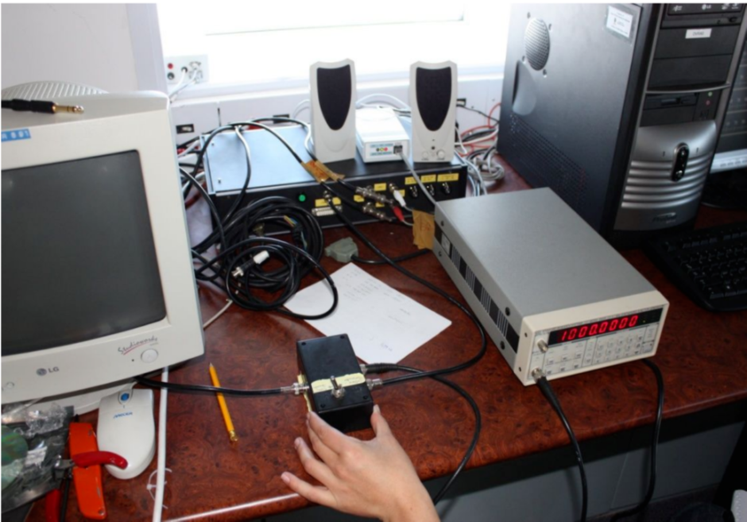

Figure 7. Impedance matching unit.

1. Switch attenuator to 20 dB on the signal conditioner in the lab.

### Field Preparations

Complete the following preparations in the field before starting with coil calibration procedure:

1. Get the calibration stick (shown in Figure 2.12) and a very tall person and/or a stepladder to stand on. Also bring a compass and an extra person (and maybe a light source to make it easier to see reflections in the mirror).
2. Reconnect the loops antenna to the required connectors on the preamplifier.
3. Align the calibration coil, mounted high on the antenna mast, to geographic bearing 0°. Use the below table as reference for bearings:

Table 2. Run: $ calibration-coil.py -17 output.

|  |  |  |  |
| --- | --- | --- | --- |
| geo | mag | mgeo | mmag |
| 0 | 17 | 270 | 287 |
| 15 | 32 | 285 | 302 |
| 30 | 47 | 300 | 317 |
| 45 | 62 | 315 | 332 |
| 60 | 77 | 330 | 347 |
| 75 | 92 | 345 | 2 |
| 90 | 107 | 0 | 17 |
| 105 | 122 | 15 | 32 |
| 120 | 137 | 30 | 47 |
| 135 | 152 | 45 | 62 |
| 150 | 167 | 60 | 77 |
| 165 | 182 | 75 | 92 |
| 180 | 197 | 90 | 107 |

1. Dress warmly, as you will be standing around a lot!

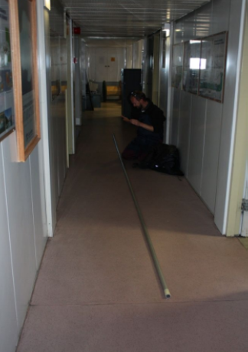

Figure 8. Calibration stick and operator.

### Procedure

1. The general procedure will have the person with the stick stay close to the mast and is ready to be able to move the coil with the mirror attached to them.
2. The person with the compass goes out to a distance of about 40 meters from the mast, and looks toward the mast. The bearing on his/her compass should show 287 deg, which correlate with 0 deg bearing.
3. The first person at the mast is now twisting the coils so that the second person can see him/herself (or the light from the torch) in the mirror Figure 2.13, Figure 2.14 and Figure 2.14.
4. When in place, and coils turned in position, wait for the lab scientists to do their measurements (don’t forget to let them know you are in place).
5. The base will transmit instructions on where to go, what bearing and when they are ready to do the next measurement.

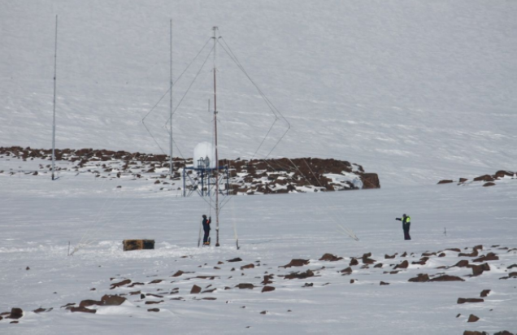

Figure 9. One person will walk around the mast in a big circle, finding the desired bearing. Once in place, they will shine a light and wait for the reflection from the mirror on top of the mast, being tuned into position by using a long poking stick.

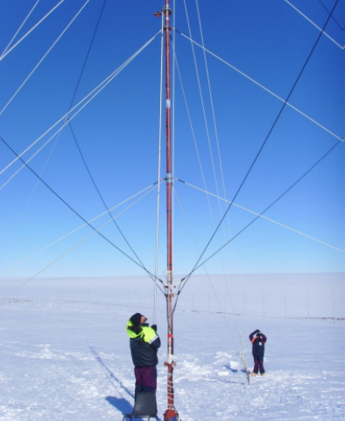

Figure 10. Twisting the location of the mirror with the stick.

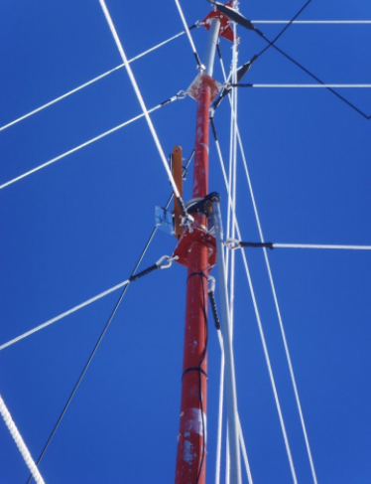

Figure 11. The stick fits into a small hole on the plate holding the mirror.

1. When confirmed from the field team that the coil is in position, proceed taking measurements for the azimuth response, with the signal generator at the specified positions and frequencies given by the program.
2. The last signal of each set will be given by the calibration recording (flick the switch to CAL) and press the green button on the signal conditioner *Figure 12*.

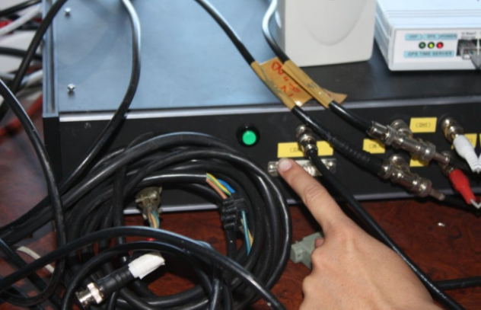

Figure 12. The green button to press for CAL recording.

1. NB: Switch back to OSCILLATOR when done! Also, the switch has three positions. Take care not to use the middle position for any of the measurements.
2. Repeat for all 13 bearings listed in 4.1, at 1, 2, 5 and 10 kHz. The field crew must move the calibration coil to the correct position 13 times for 4 frequencies.
3. The procedure is very cumbersome and take a lot of time.
4. Return the antenna to bearing 0° (287° in the field) for the calibration coil sensitivity check upon instruction from the base party.
5. After this section is completed, return the coil to bearing 45° upon instruction from the base party.
6. Start with the calibration coil sensitivity check at four frequencies on bearings 0°, 90° and 45°.
7. Request the field team to leave the calibration coil at 45° for the antenna noise.
8. Switch off the signal generator.
9. Record antenna noise by pressing enter and leave the recording to finish.
10. Start with calibration coil frequency response, with the antenna on 45 degrees. Complete the required measurements by only altering the frequency and keeping the amplitude on 0.6 Vrms.
11. When all measurements are done, return the calibration coil to geographic 45°.
12. Reconnect cable to parallel port.
13. Restart *dvrec*.